

Tarea final hito 3

*Nombre Completo: Univ. Samuel Alejandro Maldonado Garcia*

*Asignatura: Sistemas Móviles y Embebidos*

*Carrera: INGENIERÍA DE SISTEMAS*

*Paralelo: SOM (1)*

*Docente: Lic. William R. Barra Paredes*

*fecha: 06-05-2020*

1. **Diseño de un Onboarding:**

**Adapters**

**package** com.example.examenhito3.Adapters;  
  
**import** androidx.annotation.NonNull;  
**import** androidx.fragment.app.Fragment;  
**import** androidx.fragment.app.FragmentManager;  
**import** androidx.fragment.app.FragmentPagerAdapter;  
  
**import** com.example.examenhito3.Onboarding.n1;  
**import** com.example.examenhito3.Onboarding.n2;  
**import** com.example.examenhito3.Onboarding.n3;  
  
  
**public class** OnboardingAdapter **extends** FragmentPagerAdapter  
{  
 **public** OnboardingAdapter(FragmentManager fm)  
 {  
 **super**(fm);  
 }  
  
 @NonNull  
 @Override  
 **public** Fragment getItem(**int** position)  
 {  
 **switch** (position)  
 {  
 **case** 0:  
 **return new** n1();  
 **case** 1:  
 **return new** n2();  
 **case** 2:  
 **return new** n3();  
  
 **default**:  
 **return null**;  
 }  
 }  
  
 @Override  
 **public int** getCount()  
 {  
 **return** 3;  
 }  
}

**Primera pantalla**

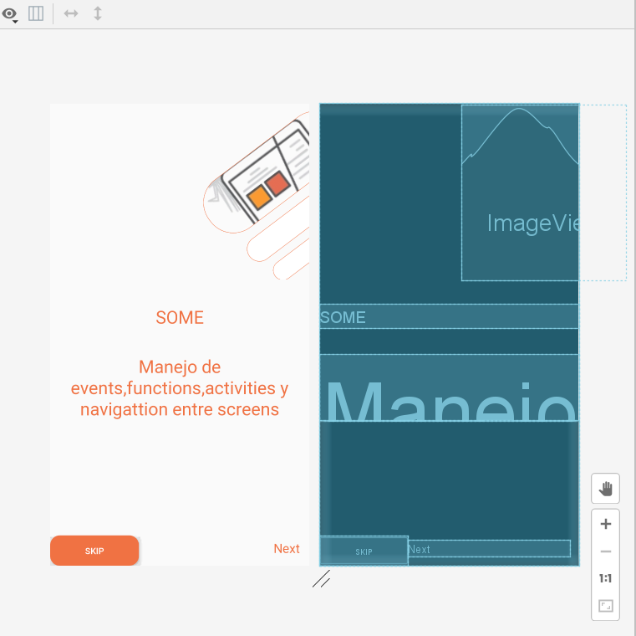

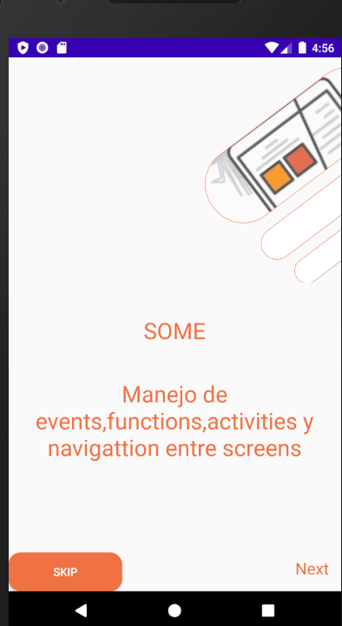

**Código:**

**Xml:**

*<?***xml version="1.0" encoding="utf-8"***?>*<**LinearLayout xmlns:android="http://schemas.android.com/apk/res/android"  
 xmlns:tools="http://schemas.android.com/tools"  
 android:layout_width="match_parent"  
 android:layout_height="match_parent"  
 tools:context=".Onboarding.n1"  
 android:orientation="vertical"**>  
 <**ImageView  
 android:id="@+id/ima"  
 android:layout_width="wrap_content"  
 android:layout_height="277dp"  
 android:layout_gravity="center"  
 android:layout_marginLeft="150dp"  
 android:layout_marginTop="1dp"  
 android:scaleType="centerCrop"  
 android:src="@drawable/img1"** />  
 <**TextView  
 android:id="@+id/textTitle1"  
 android:layout_width="match_parent"  
 android:layout_height="wrap_content"  
 android:layout_marginTop="40dp"  
 android:fontFamily="sans-serif"  
 android:gravity="center"  
 android:text="@string/titulo"  
 android:textColor="@color/colorPrimary"  
 android:textSize="28sp"** />  
 <**TextView  
 android:id="@+id/textlar"  
 android:layout_width="match_parent"  
 android:layout_height="wrap_content"  
 android:layout_marginTop="40dp"  
 android:fontFamily="sans-serif"  
 android:gravity="center"  
 android:text="@string/manejo"  
 android:textColor="@color/colorPrimary"  
 android:textSize="28sp"** />  
 <**LinearLayout  
 android:id="@+id/layoutNext"  
 android:layout_width="match_parent"  
 android:layout_height="match_parent"  
 android:orientation="horizontal"**>  
 <**Button  
 android:id="@+id/skip1"  
 android:layout_width="141dp"  
 android:layout_height="wrap_content"  
 android:layout_gravity="bottom|start"  
 android:background="@drawable/stylesnt"  
 android:text="@string/skip"  
 android:textColor="@color/colorWhite"**>  
 </**Button**>  
 <**TextView  
 android:id="@+id/textInc"  
 android:layout_width="wrap_content"  
 android:layout_height="wrap_content"  
 android:layout_gravity="bottom|start"  
 android:layout_marginRight="15dp"  
 android:layout_marginBottom="2dp"  
 android:layout_weight="1"  
 android:clickable="true"  
 android:focusable="true"  
 android:fontFamily="sans-serif"  
 android:gravity="bottom|end"  
 android:text="@string/done"  
 android:textColor="@color/colorPrimary"  
 android:textSize="20sp"**/>  
 </**LinearLayout**>  
</**LinearLayout**>

**Java**

**package** com.example.examenhito3.Onboarding;  
  
**import** android.os.Bundle;  
  
**import** androidx.fragment.app.Fragment;  
**import** androidx.viewpager.widget.ViewPager;  
  
**import** android.view.LayoutInflater;  
**import** android.view.View;  
**import** android.view.ViewGroup;  
**import** android.widget.Button;  
**import** android.widget.TextView;  
  
**import** com.example.examenhito3.R;  
  
*/**  
 * A simple {****@link*** *Fragment} subclass.  
 */***public class** n1 **extends** Fragment {  
 **private** ViewPager **viewPager**;  
 **private** View **view**;  
 TextView **textNextFace**;  
 Button **Next**;  
 **public** n1() {  
 *// Required empty public constructor* }  
  
  
 @Override  
 **public** View onCreateView(LayoutInflater inflater, ViewGroup container,  
 Bundle savedInstanceState) {  
 *//initialize viewpager from main activity* initializeInflater(inflater, container);  
  
 *//initialize components* initializeComponents();  
  
 *//add click event to text Next and prev text* addClickNextAndPrev();  
  
 *//return* **return view**;  
 }  
  
 **public void** initializeInflater(LayoutInflater inflater, ViewGroup container) {  
 **view** = inflater.inflate(R.layout.***fragment_n1***, container, **false**);  
 }  
  
 **public void** initializeComponents() {  
 **viewPager** = getActivity().findViewById(R.id.***viewPagerContainer***);  
  
 **textNextFace** = **view**.findViewById(R.id.***textInc***);  
 **Next**=**view**.findViewById(R.id.***skip1***);  
 }  
  
 **public void** addClickNextAndPrev() {  
  
 **textNextFace**.setOnClickListener(**new** View.OnClickListener() {  
 @Override  
 **public void** onClick(View v) {  
 **viewPager**.setCurrentItem(1);  
 }  
 });  
 **Next**.setOnClickListener(**new** View.OnClickListener() {  
 @Override  
 **public void** onClick(View v) {  
 **viewPager**.setCurrentItem(2);  
 }  
 });  
 }  
}

**Segunda Pantalla 2**

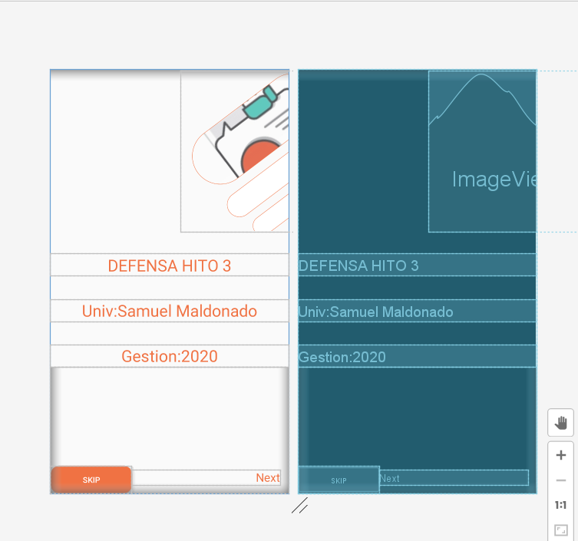

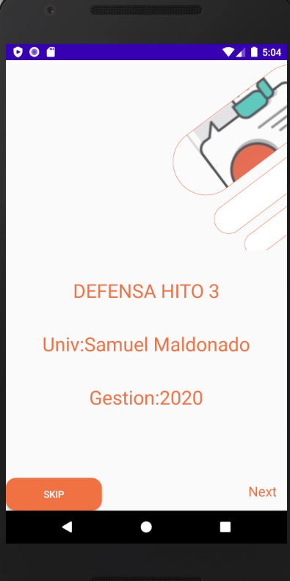

**Código:**

**Xml:**

*<?***xml version="1.0" encoding="utf-8"***?>*<**LinearLayout xmlns:android="http://schemas.android.com/apk/res/android"  
 xmlns:tools="http://schemas.android.com/tools"  
 android:layout_width="match_parent"  
 android:layout_height="match_parent"  
 tools:context=".Onboarding.n2"  
 android:orientation="vertical"**>  
 <**ImageView  
 android:id="@+id/ima"  
 android:layout_width="wrap_content"  
 android:layout_height="277dp"  
 android:layout_gravity="center"  
 android:layout_marginLeft="150dp"  
 android:layout_marginTop="1dp"  
 android:scaleType="centerCrop"  
 android:src="@drawable/img2"** />  
 <**TextView  
 android:id="@+id/textTitle1"  
 android:layout_width="match_parent"  
 android:layout_height="wrap_content"  
 android:layout_marginTop="40dp"  
 android:fontFamily="sans-serif"  
 android:gravity="center"  
 android:text="@string/titulo2"  
 android:textColor="@color/colorPrimary"  
 android:textSize="28sp"** />  
 <**TextView  
 android:id="@+id/textlar"  
 android:layout_width="match_parent"  
 android:layout_height="wrap_content"  
 android:layout_marginTop="40dp"  
 android:fontFamily="sans-serif"  
 android:gravity="center"  
 android:text="@string/manejo2"  
 android:textColor="@color/colorPrimary"  
 android:textSize="28sp"** />  
 <**TextView  
 android:id="@+id/gest"  
 android:layout_width="match_parent"  
 android:layout_height="wrap_content"  
 android:layout_marginTop="40dp"  
 android:fontFamily="sans-serif"  
 android:gravity="center"  
 android:text="@string/estion"  
 android:textColor="@color/colorPrimary"  
 android:textSize="28sp"** />  
 <**LinearLayout  
 android:id="@+id/layoutNext"  
 android:layout_width="match_parent"  
 android:layout_height="match_parent"  
 android:orientation="horizontal"**>  
 <**Button  
 android:id="@+id/skip2"  
 android:layout_width="141dp"  
 android:layout_height="wrap_content"  
 android:layout_gravity="bottom|start"  
 android:background="@drawable/stylesnt"  
 android:text="@string/skip"  
 android:textColor="@color/colorWhite"**>  
 </**Button**>  
 <**TextView  
 android:id="@+id/textInc2"  
 android:layout_width="wrap_content"  
 android:layout_height="wrap_content"  
 android:layout_gravity="bottom|start"  
 android:layout_marginRight="15dp"  
 android:layout_marginBottom="2dp"  
 android:layout_weight="1"  
 android:clickable="true"  
 android:focusable="true"  
 android:fontFamily="sans-serif"  
 android:gravity="bottom|end"  
 android:text="@string/done"  
 android:textColor="@color/colorPrimary"  
 android:textSize="20sp"** />  
 </**LinearLayout**>  
</**LinearLayout**>

**Java:**

**package** com.example.examenhito3.Onboarding;  
  
**import** android.os.Bundle;  
  
**import** androidx.fragment.app.Fragment;  
**import** androidx.viewpager.widget.ViewPager;  
  
**import** android.view.LayoutInflater;  
**import** android.view.View;  
**import** android.view.ViewGroup;  
**import** android.widget.Button;  
**import** android.widget.TextView;  
  
**import** com.example.examenhito3.R;  
  
*/**  
 * A simple {****@link*** *Fragment} subclass.  
 */***public class** n2 **extends** Fragment {  
 **private** ViewPager **viewPager**;  
 **private** View **view**;  
 TextView **textNextFace2**;  
 Button **Next2**;  
 **public** n2() {  
 *// Required empty public constructor* }  
  
  
 @Override  
 **public** View onCreateView(LayoutInflater inflater, ViewGroup container,  
 Bundle savedInstanceState) {  
 initializeInflater(inflater, container);  
  
 *//initialize components* initializeComponents();  
  
 *//add click event to text Next and prev text* addClickNextAndPrev();  
  
 *//return* **return view**;  
 }  
 **public void** initializeInflater(LayoutInflater inflater, ViewGroup container) {  
 **view** = inflater.inflate(R.layout.***fragment_n2***, container, **false**);  
 }  
  
 **public void** initializeComponents() {  
 **viewPager** = getActivity().findViewById(R.id.***viewPagerContainer***);  
  
 **textNextFace2** = **view**.findViewById(R.id.***textInc2***);  
 **Next2**=**view**.findViewById(R.id.***skip2***);  
 }  
  
 **public void** addClickNextAndPrev() {  
  
 **textNextFace2**.setOnClickListener(**new** View.OnClickListener() {  
 @Override  
 **public void** onClick(View v) {  
 **viewPager**.setCurrentItem(2);  
 }  
 });  
 **Next2**.setOnClickListener(**new** View.OnClickListener() {  
 @Override  
 **public void** onClick(View v) {  
 **viewPager**.setCurrentItem(2);  
 }  
 });  
 }  
}

**Tercera pantalla**

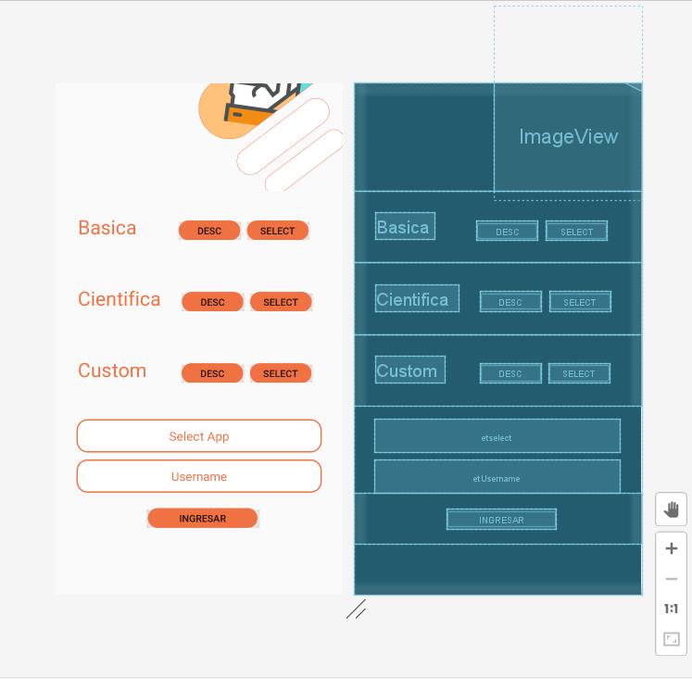

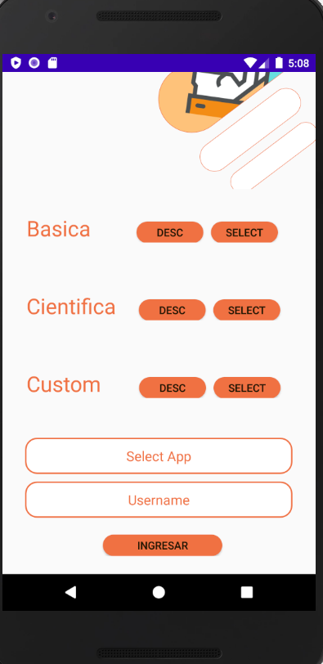

**Código:**

**Xml:**

*<?***xml version="1.0" encoding="utf-8"***?>*<**LinearLayout xmlns:android="http://schemas.android.com/apk/res/android"  
 xmlns:tools="http://schemas.android.com/tools"  
 android:layout_width="match_parent"  
 android:layout_height="match_parent"  
 tools:context=".Onboarding.n1"  
 android:orientation="vertical"**>  
 <**LinearLayout  
 android:layout_width="match_parent"  
 android:layout_height="154dp"  
 android:gravity="center"  
 android:orientation="horizontal"**>  
 <**ImageView  
 android:id="@+id/ima"  
 android:layout_width="wrap_content"  
 android:layout_height="277dp"  
 android:layout_gravity="center"  
 android:layout_marginLeft="200dp"  
 android:layout_marginBottom="50dp"  
 android:scaleType="centerCrop"  
 android:src="@drawable/img3"** />  
 </**LinearLayout**>  
 <**LinearLayout  
 android:layout_width="match_parent"  
 android:layout_height="wrap_content"  
 android:orientation="horizontal"  
 android:padding="32dp"**>  
 <**TextView  
 android:layout_width="wrap_content"  
 android:layout_height="wrap_content"  
 android:fontFamily="sans-serif"  
 android:text="@string/asica"  
 android:textColor="@color/colorPrimary"  
 android:textSize="28sp"** />  
 <**Button  
 android:id="@+id/d1"  
 android:layout_width="wrap_content"  
 android:layout_height="28dp"  
 android:layout_marginLeft="60dp"  
 android:background="@drawable/stylesnt"  
 android:text="@string/Dex"** />  
 <**Button  
 android:id="@+id/s1"  
 android:layout_width="wrap_content"  
 android:layout_height="28dp"  
 android:layout_marginLeft="10dp"  
 android:background="@drawable/stylesnt"  
 android:text="@string/select"** />  
 </**LinearLayout**>  
 <**LinearLayout  
 android:layout_width="match_parent"  
 android:layout_height="wrap_content"  
 android:orientation="horizontal"  
 android:padding="32dp"**>  
 <**TextView  
 android:layout_width="wrap_content"  
 android:layout_height="wrap_content"  
 android:fontFamily="sans-serif"  
 android:text="@string/asica1"  
 android:textColor="@color/colorPrimary"  
 android:textSize="28sp"** />  
 <**Button  
 android:id="@+id/d2"  
 android:layout_width="wrap_content"  
 android:layout_height="28dp"  
 android:layout_marginLeft="30dp"  
 android:background="@drawable/stylesnt"  
 android:text="@string/Dex"** />  
 <**Button  
 android:id="@+id/s2"  
 android:layout_width="wrap_content"  
 android:layout_height="28dp"  
 android:layout_marginLeft="10dp"  
 android:background="@drawable/stylesnt"  
 android:text="@string/select"** />  
 </**LinearLayout**>  
 <**LinearLayout  
 android:layout_width="match_parent"  
 android:layout_height="wrap_content"  
 android:orientation="horizontal"  
 android:padding="32dp"**>  
 <**TextView  
 android:layout_width="wrap_content"  
 android:layout_height="wrap_content"  
 android:fontFamily="sans-serif"  
 android:text="@string/asica2"  
 android:textColor="@color/colorPrimary"  
 android:textSize="28sp"** />  
 <**Button  
 android:id="@+id/d3"  
 android:layout_width="wrap_content"  
 android:layout_height="28dp"  
 android:layout_marginLeft="50dp"  
 android:background="@drawable/stylesnt"  
 android:text="@string/Dex"** />  
 <**Button  
 android:id="@+id/s3"  
 android:layout_width="wrap_content"  
 android:layout_height="28dp"  
 android:layout_marginLeft="10dp"  
 android:background="@drawable/stylesnt"  
 android:text="@string/select"** />  
 </**LinearLayout**>  
 <**EditText  
 android:id="@+id/etselect"  
 android:layout_width="match_parent"  
 android:layout_height="wrap_content"  
 android:layout_gravity="center"  
 android:layout_marginLeft="30dp"  
 android:layout_marginTop="20dp"  
 android:layout_marginRight="30dp"  
 android:background="@drawable/et_style"  
 android:fontFamily="sans-serif"  
 android:hint="@string/selecapp"  
 android:textColorHint="@color/colorPrimary"  
 android:inputType="textEmailAddress"  
 android:textAlignment="center"**>  
 </**EditText**>  
 <**EditText  
 android:id="@+id/etUsername"  
 android:layout_width="match_parent"  
 android:layout_height="wrap_content"  
 android:layout_gravity="center"  
 android:layout_marginLeft="30dp"  
 android:layout_marginTop="10dp"  
 android:layout_marginRight="30dp"  
 android:background="@drawable/et_style"  
 android:fontFamily="sans-serif"  
 android:hint="@string/username"  
 android:textColorHint="@color/colorPrimary"  
 android:textAlignment="center"**>  
 </**EditText**>  
 <**LinearLayout  
 android:layout_width="match_parent"  
 android:layout_height="wrap_content"  
 android:orientation="horizontal"  
 android:padding="22dp"  
 android:gravity="center"**>  
 <**Button  
 android:id="@+id/btnIn"  
 android:layout_width="157dp"  
 android:layout_height="28dp"  
 android:layout_marginLeft="10dp"  
 android:background="@drawable/stylesnt"  
 android:text="@string/in"** />  
 </**LinearLayout**>  
</**LinearLayout**>

**Java:**

**package** com.example.examenhito3.Onboarding;  
  
**import** android.content.Intent;  
**import** android.os.Bundle;  
  
**import** androidx.fragment.app.Fragment;  
**import** androidx.viewpager.widget.ViewPager;  
  
**import** android.view.LayoutInflater;  
**import** android.view.View;  
**import** android.view.ViewGroup;  
**import** android.widget.Button;  
**import** android.widget.EditText;  
**import** android.widget.TextView;  
**import** android.widget.Toast;  
  
**import** com.example.examenhito3.App.CalcBasica;  
**import** com.example.examenhito3.App.CalcCientiffica;  
**import** com.example.examenhito3.App.CalcCustom;  
**import** com.example.examenhito3.R;  
  
  
*/**  
 * A simple {****@link*** *Fragment} subclass.  
 */***public class** n3 **extends** Fragment  
{  
  
 **private** ViewPager **viewPager**;  
 **private** View **view**;  
 **private** Button **bti**,**d1**,**d2**,**d3**,**s1**,**s2**,**s3**;  
 **private** EditText **etsel**,**etUser**;  
  
 **public** n3()  
 {  
 *// Required empty public constructor* }  
  
 @Override  
 **public** View onCreateView(LayoutInflater inflater, ViewGroup container, Bundle savedInstanceState)  
 {  
 *//initialize viewpager from main activity* initializeInflater(inflater, container);  
  
 *//initialize components* initializeComponents();  
  
 *//add click event to text Next and prev text* eventClickAction();  
  
 *//return* **return view**;  
 }  
  
 **public void** initializeInflater(LayoutInflater inflater, ViewGroup container)  
 {  
 **view** = inflater.inflate(R.layout.***fragment_n3***, container, **false**);  
 }  
  
 **public void** initializeComponents()  
 {  
 **viewPager** = getActivity().findViewById(R.id.***viewPagerContainer***);  
  
  
 **d1** = **view**.findViewById(R.id.***d1***);  
 **d2** = **view**.findViewById(R.id.***d2***);  
 **d3** = **view**.findViewById(R.id.***d3***);  
 **s1** = **view**.findViewById(R.id.***s1***);  
 **s2** = **view**.findViewById(R.id.***s2***);  
 **s3** = **view**.findViewById(R.id.***s3***);  
 **etsel** = **view**.findViewById(R.id.***etselect***);  
 **etUser** = **view**.findViewById(R.id.***etUsername***);  
 **bti** = **view**.findViewById(R.id.***btnIn***);  
 }  
  
 **public void** eventClickAction()  
 {  
**d1**.setOnClickListener(**new** View.OnClickListener() {  
 @Override  
 **public void** onClick(View v) {  
 Toast.*makeText*(getActivity(), **"Calculadora con operaciones simples básica"**, Toast.***LENGTH_SHORT***).show();  
 }  
});  
 **d2**.setOnClickListener(**new** View.OnClickListener() {  
 @Override  
 **public void** onClick(View v) {  
 Toast.*makeText*(getActivity(), **"Calculadora con operaciones avanzadas"**, Toast.***LENGTH_SHORT***).show();  
 }  
 });  
 **d3**.setOnClickListener(**new** View.OnClickListener() {  
 @Override  
 **public void** onClick(View v) {  
 Toast.*makeText*(getActivity(), **"Calculadora con operaciones para programadores"**, Toast.***LENGTH_SHORT***).show();  
 }  
 });  
 **s1**.setOnClickListener(**new** View.OnClickListener() {  
 @Override  
 **public void** onClick(View v) {  
 **etsel**.setText(**"Basica"**);  
 }  
 });  
 **s2**.setOnClickListener(**new** View.OnClickListener() {  
 @Override  
 **public void** onClick(View v) {  
 **etsel**.setText(**"Cientifica"**);  
 }  
 });  
 **s3**.setOnClickListener(**new** View.OnClickListener() {  
 @Override  
 **public void** onClick(View v) {  
 **etsel**.setText(**"Custom"**);  
 }  
 });  
  
 **bti**.setOnClickListener(**new** View.OnClickListener()  
 {  
 @Override  
 **public void** onClick(View v)  
 {  
 String selct = **etsel**.getText().toString().trim();  
 String username = **etUser**.getText().toString().trim();  
  
 **if**(username.equals(**""**) || selct .equals(**""**))  
 {  
 Toast.*makeText*(getActivity(), **"Ingrese Select/Username"**, Toast.***LENGTH_SHORT***).show();  
 }  
 **else if**(selct.equals(**"Custom"**))  
 {  
 Intent intent = **new** Intent(getActivity(), CalcCustom.**class**);  
 intent.putExtra(**"US"**, username);  
 intent.putExtra(**"AS"**, selct);  
 startActivity(intent);  
 getActivity().finish();  
 }  
 **else if**(selct.equals(**"Basica"**))  
 {  
 Intent intent = **new** Intent(getActivity(), CalcBasica.**class**);  
 intent.putExtra(**"US"**, username);  
 intent.putExtra(**"AS"**, selct);  
 startActivity(intent);  
 getActivity().finish();  
 }  
 **else if**(selct.equals(**"Cientifica"**))  
 {  
 Intent intent = **new** Intent(getActivity(), CalcCientiffica.**class**);  
 intent.putExtra(**"US"**, username);  
 intent.putExtra(**"AS"**, selct);  
 startActivity(intent);  
 getActivity().finish();  
 }  
 **else**{  
 Toast.*makeText*(getActivity(), **"Seleccione alguna calculadora"**, Toast.***LENGTH_SHORT***).show();  
 }  
 }  
 });  
 }  
}

**Strings:**

<**string name="titulo"**>SOME</**string**>  
<**string name="titulo2"**>DEFENSA HITO 3</**string**>  
<**string name="manejo2"**>Univ:Samuel Maldonado</**string**>  
<**string name="estion"**>Gestion:2020</**string**>  
<**string name="done"**>Next</**string**>>  
<**string name="skip"**>Skip</**string**>  
<**string name="asica"**>Basica</**string**>  
<**string name="asica1"**>Cientifica</**string**>  
<**string name="asica2"**>Custom</**string**>  
<**string name="selecapp"**>Select App</**string**>  
<**string name="username"**>Username</**string**>  
<**string name="in"**>Ingresar</**string**>  
<**string name="select"**>Select</**string**>  
<**string name="Dex"**>Desc</**string**>  
<**string name="manejo"**>Manejo de events,functions,activities y navigattion entre screens</**string**>  
<**string name="mas"**>+</**string**>  
<**string name="menos"**>-</**string**>  
<**string name="multi"**>*</**string**>  
<**string name="di"**>/</**string**>  
<**string name="nume1"**>1</**string**>  
<**string name="nume2"**>2</**string**>  
<**string name="nume3"**>3</**string**>  
<**string name="nume4"**>4</**string**>  
<**string name="nume5"**>5</**string**>  
<**string name="nume6"**>6</**string**>  
<**string name="nume7"**>7</**string**>  
<**string name="nume8"**>8</**string**>  
<**string name="nume9"**>9</**string**>  
<**string name="nume0"**>0</**string**>  
<**string name="masmenos"**>+/-</**string**>  
<**string name="punto"**>.</**string**>  
<**string name="iual"**>=</**string**>  
<**string name="mass"**>+</**string**>  
<**string name="menoss"**>-</**string**>  
<**string name="multii"**>*</**string**>  
<**string name="dis"**>/</**string**>  
<**string name="c"**>C</**string**>  
<**string name="c2"**>C2</**string**>  
<**string name="flecha"**>(-</**string**>  
<**string name="cuadrado"**>x2</**string**>  
<**string name="porcentaje"**>%</**string**>  
<**string name="R"**>R</**string**>

**Colores:**

<**color name="colorWhite"**>#FFFFFF</**color**>  
<**color name="colorPrimary"**>#F07243  
</**color**>  
<**color name="colorPrimaryDark"**>#3700B3</**color**>  
<**color name="colorAccent"**>#03DAC5</**color**>

**Estilos:**

*<?***xml version="1.0" encoding="utf-8"***?>*<**shape xmlns:android="http://schemas.android.com/apk/res/android"**>  
 <**solid android:color="@color/colorPrimary"**/>  
 <**corners android:radius="15dp"**/>  
 <**stroke android:width="1dp" android:color="@color/colorPrimary"**/>  
</**shape**>

*<?***xml version="1.0" encoding="utf-8"***?>*<**shape xmlns:android="http://schemas.android.com/apk/res/android"**>  
 <**solid android:color="@color/colorAccent"**/>  
 <**corners android:radius="15dp"**/>  
 <**stroke android:width="1dp" android:color="@color/colorAccent"**/>  
</**shape**>

*<?***xml version="1.0" encoding="utf-8"***?>*<**shape xmlns:android="http://schemas.android.com/apk/res/android"**>  
  
 <**solid android:color="@color/colorWhite"**></**solid**>  
 <**corners android:radius="15dp"**></**corners**>  
 <**stroke android:width="2dp" android:color="@color/colorPrimary"**></**stroke**>  
 <**padding android:top="12dp" android:bottom="12dp" android:left="12dp" android:right="12dp"**></**padding**>  
  
</**shape**>

1. **CALCULADORA CIENTIFICA**

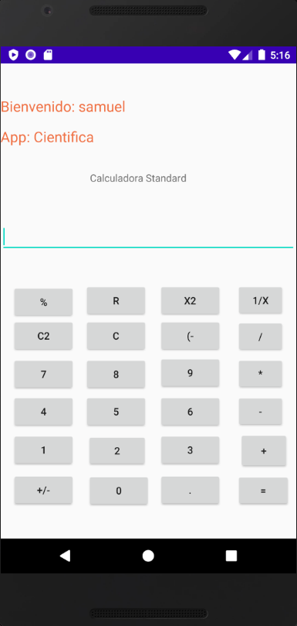

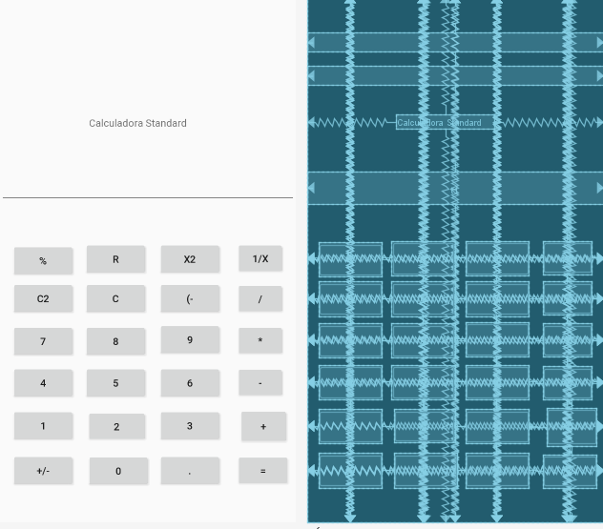

**Xml:**

*<?***xml version="1.0" encoding="utf-8"***?>*<**androidx.constraintlayout.widget.ConstraintLayout xmlns:android="http://schemas.android.com/apk/res/android"  
xmlns:app="http://schemas.android.com/apk/res-auto"  
xmlns:tools="http://schemas.android.com/tools"  
android:layout_width="match_parent"  
android:layout_height="match_parent"  
tools:context=".MainActivity"**>  
  
 <**TextView  
 android:id="@+id/tvShowU1"  
 android:layout_width="match_parent"  
 android:layout_height="wrap_content"  
 android:textColor="@color/colorPrimary"  
 android:textSize="20sp"  
 app:layout_constraintBottom_toBottomOf="parent"  
 app:layout_constraintHorizontal_bias="0.0"  
 app:layout_constraintLeft_toLeftOf="parent"  
 app:layout_constraintRight_toRightOf="parent"  
 app:layout_constraintTop_toTopOf="parent"  
 app:layout_constraintVertical_bias="0.072"**>  
 </**TextView**>  
 <**TextView  
 android:id="@+id/tvShowS1"  
 android:layout_width="match_parent"  
 android:layout_height="wrap_content"  
 android:textColor="@color/colorPrimary"  
 android:textSize="20sp"  
 app:layout_constraintBottom_toBottomOf="parent"  
 app:layout_constraintHorizontal_bias="1.0"  
 app:layout_constraintLeft_toLeftOf="parent"  
 app:layout_constraintRight_toRightOf="parent"  
 app:layout_constraintTop_toTopOf="parent"  
 app:layout_constraintVertical_bias="0.139"**>  
 </**TextView**>  
 <**Button  
 android:id="@+id/numc2"  
 android:layout_width="wrap_content"  
 android:layout_height="wrap_content"  
 android:text="@string/c2"  
 app:layout_constraintBottom_toBottomOf="parent"  
 app:layout_constraintHorizontal_bias="0.049"  
 app:layout_constraintLeft_toLeftOf="parent"  
 app:layout_constraintRight_toRightOf="parent"  
 app:layout_constraintTop_toTopOf="parent"  
 app:layout_constraintVertical_bias="0.579"** />  
<**Button  
 android:id="@+id/multi"  
 android:layout_width="67dp"  
 android:layout_height="47dp"  
 android:text="@string/multi"  
 app:layout_constraintBottom_toBottomOf="parent"  
 app:layout_constraintHorizontal_bias="0.953"  
 app:layout_constraintLeft_toLeftOf="parent"  
 app:layout_constraintRight_toRightOf="parent"  
 app:layout_constraintTop_toTopOf="parent"  
 app:layout_constraintVertical_bias="0.665"** />  
<**Button  
 android:id="@+id/num6"  
 android:layout_width="wrap_content"  
 android:layout_height="wrap_content"  
 android:text="@string/nume6"  
 app:layout_constraintBottom_toBottomOf="parent"  
 app:layout_constraintHorizontal_bias="0.681"  
 app:layout_constraintLeft_toLeftOf="parent"  
 app:layout_constraintRight_toRightOf="parent"  
 app:layout_constraintTop_toTopOf="parent"  
 app:layout_constraintVertical_bias="0.751"** />  
<**Button  
 android:id="@+id/num9"  
 android:layout_width="wrap_content"  
 android:layout_height="wrap_content"  
 android:text="@string/nume9"  
 app:layout_constraintBottom_toBottomOf="parent"  
 app:layout_constraintHorizontal_bias="0.681"  
 app:layout_constraintLeft_toLeftOf="parent"  
 app:layout_constraintRight_toRightOf="parent"  
 app:layout_constraintTop_toTopOf="parent"  
 app:layout_constraintVertical_bias="0.663"** />  
<**Button  
 android:id="@+id/num4"  
 android:layout_width="wrap_content"  
 android:layout_height="wrap_content"  
 android:text="@string/nume4"  
 app:layout_constraintBottom_toBottomOf="parent"  
 app:layout_constraintHorizontal_bias="0.049"  
 app:layout_constraintLeft_toLeftOf="parent"  
 app:layout_constraintRight_toRightOf="parent"  
 app:layout_constraintTop_toTopOf="parent"  
 app:layout_constraintVertical_bias="0.751"** />  
<**Button  
 android:id="@+id/num5"  
 android:layout_width="wrap_content"  
 android:layout_height="wrap_content"  
 android:text="@string/nume5"  
 app:layout_constraintBottom_toBottomOf="parent"  
 app:layout_constraintHorizontal_bias="0.362"  
 app:layout_constraintLeft_toLeftOf="parent"  
 app:layout_constraintRight_toRightOf="parent"  
 app:layout_constraintTop_toTopOf="parent"  
 app:layout_constraintVertical_bias="0.751"** />  
<**Button  
 android:id="@+id/masmenos"  
 android:layout_width="wrap_content"  
 android:layout_height="wrap_content"  
 android:text="@string/masmenos"  
 app:layout_constraintBottom_toBottomOf="parent"  
 app:layout_constraintHorizontal_bias="0.049"  
 app:layout_constraintLeft_toLeftOf="parent"  
 app:layout_constraintRight_toRightOf="parent"  
 app:layout_constraintTop_toTopOf="parent"  
 app:layout_constraintVertical_bias="0.929"** />  
<**Button  
 android:id="@+id/numc"  
 android:layout_width="wrap_content"  
 android:layout_height="wrap_content"  
 android:text="@string/c"  
 app:layout_constraintBottom_toBottomOf="parent"  
 app:layout_constraintHorizontal_bias="0.362"  
 app:layout_constraintLeft_toLeftOf="parent"  
 app:layout_constraintRight_toRightOf="parent"  
 app:layout_constraintTop_toTopOf="parent"  
 app:layout_constraintVertical_bias="0.579"** />  
<**Button  
 android:id="@+id/num8"  
 android:layout_width="wrap_content"  
 android:layout_height="wrap_content"  
 android:text="@string/nume8"  
 app:layout_constraintBottom_toBottomOf="parent"  
 app:layout_constraintHorizontal_bias="0.362"  
 app:layout_constraintLeft_toLeftOf="parent"  
 app:layout_constraintRight_toRightOf="parent"  
 app:layout_constraintTop_toTopOf="parent"  
 app:layout_constraintVertical_bias="0.666"** />  
 <**EditText  
 android:id="@+id/t1"  
 android:layout_width="match_parent"  
 android:layout_height="wrap_content"  
 app:layout_constraintBottom_toBottomOf="parent"  
 app:layout_constraintHorizontal_bias="0.0"  
 app:layout_constraintLeft_toLeftOf="parent"  
 app:layout_constraintRight_toRightOf="parent"  
 app:layout_constraintTop_toTopOf="parent"  
 app:layout_constraintVertical_bias="0.355"** />  
 <**Button  
 android:id="@+id/num1"  
 android:layout_width="wrap_content"  
 android:layout_height="wrap_content"  
 android:text="@string/nume1"  
 app:layout_constraintBottom_toBottomOf="parent"  
 app:layout_constraintHorizontal_bias="0.049"  
 app:layout_constraintLeft_toLeftOf="parent"  
 app:layout_constraintRight_toRightOf="parent"  
 app:layout_constraintTop_toTopOf="parent"  
 app:layout_constraintVertical_bias="0.838"** />  
<**Button  
 android:id="@+id/num3"  
 android:layout_width="wrap_content"  
 android:layout_height="wrap_content"  
 android:text="@string/nume3"  
 app:layout_constraintBottom_toBottomOf="parent"  
 app:layout_constraintHorizontal_bias="0.681"  
 app:layout_constraintLeft_toLeftOf="parent"  
 app:layout_constraintRight_toRightOf="parent"  
 app:layout_constraintTop_toTopOf="parent"  
 app:layout_constraintVertical_bias="0.838"** />  
<**Button  
 android:id="@+id/num2"  
 android:layout_width="84dp"  
 android:layout_height="47dp"  
 android:text="@string/nume2"  
 app:layout_constraintBottom_toBottomOf="parent"  
 app:layout_constraintHorizontal_bias="0.368"  
 app:layout_constraintLeft_toLeftOf="parent"  
 app:layout_constraintRight_toRightOf="parent"  
 app:layout_constraintTop_toTopOf="parent"  
 app:layout_constraintVertical_bias="0.839"** />  
<**Button  
 android:id="@+id/cuadrado"  
 android:layout_width="wrap_content"  
 android:layout_height="wrap_content"  
 android:text="@string/cuadrado"  
 app:layout_constraintBottom_toBottomOf="parent"  
 app:layout_constraintHorizontal_bias="0.681"  
 app:layout_constraintLeft_toLeftOf="parent"  
 app:layout_constraintRight_toRightOf="parent"  
 app:layout_constraintTop_toTopOf="parent"  
 app:layout_constraintVertical_bias="0.499"** />  
<**Button  
 android:id="@+id/numflechita"  
 android:layout_width="wrap_content"  
 android:layout_height="wrap_content"  
 android:text="@string/flecha"  
 app:layout_constraintBottom_toBottomOf="parent"  
 app:layout_constraintHorizontal_bias="0.681"  
 app:layout_constraintLeft_toLeftOf="parent"  
 app:layout_constraintRight_toRightOf="parent"  
 app:layout_constraintTop_toTopOf="parent"  
 app:layout_constraintVertical_bias="0.579"** />  
<**Button  
 android:id="@+id/sum"  
 android:layout_width="69dp"  
 android:layout_height="52dp"  
 android:layout_marginStart="24dp"  
 android:text="@string/mas"  
 app:layout_constraintBottom_toBottomOf="parent"  
 app:layout_constraintHorizontal_bias="0.918"  
 app:layout_constraintLeft_toLeftOf="parent"  
 app:layout_constraintRight_toRightOf="parent"  
 app:layout_constraintStart_toEndOf="@+id/num3"  
 app:layout_constraintTop_toTopOf="parent"  
 app:layout_constraintVertical_bias="0.842"** />  
<**Button  
 android:id="@+id/num0"  
 android:layout_width="wrap_content"  
 android:layout_height="wrap_content"  
 android:text="@string/nume0"  
 app:layout_constraintBottom_toBottomOf="parent"  
 app:layout_constraintHorizontal_bias="0.373"  
 app:layout_constraintLeft_toLeftOf="parent"  
 app:layout_constraintRight_toRightOf="parent"  
 app:layout_constraintTop_toTopOf="parent"  
 app:layout_constraintVertical_bias="0.93"** />  
<**Button  
 android:id="@+id/punto"  
 android:layout_width="wrap_content"  
 android:layout_height="wrap_content"  
 android:text="@string/punto"  
 app:layout_constraintBottom_toBottomOf="parent"  
 app:layout_constraintHorizontal_bias="0.681"  
 app:layout_constraintLeft_toLeftOf="parent"  
 app:layout_constraintRight_toRightOf="parent"  
 app:layout_constraintTop_toTopOf="parent"  
 app:layout_constraintVertical_bias="0.929"** />  
  
<**Button  
 android:id="@+id/igual"  
 android:layout_width="75dp"  
 android:layout_height="47dp"  
 android:text="="  
 app:layout_constraintBottom_toBottomOf="parent"  
 app:layout_constraintHorizontal_bias="0.976"  
 app:layout_constraintLeft_toLeftOf="parent"  
 app:layout_constraintRight_toRightOf="parent"  
 app:layout_constraintTop_toTopOf="parent"  
 app:layout_constraintVertical_bias="0.929"** />  
  
<**Button  
 android:id="@+id/unox"  
 android:layout_width="67dp"  
 android:layout_height="47dp"  
 android:text="1/x"  
 app:layout_constraintBottom_toBottomOf="parent"  
 app:layout_constraintHorizontal_bias="0.953"  
 app:layout_constraintLeft_toLeftOf="parent"  
 app:layout_constraintRight_toRightOf="parent"  
 app:layout_constraintTop_toTopOf="parent"  
 app:layout_constraintVertical_bias="0.498"** />  
  
<**Button  
 android:id="@+id/num7"  
 android:layout_width="wrap_content"  
 android:layout_height="wrap_content"  
 android:text="@string/nume7"  
 app:layout_constraintBottom_toBottomOf="parent"  
 app:layout_constraintHorizontal_bias="0.049"  
 app:layout_constraintLeft_toLeftOf="parent"  
 app:layout_constraintRight_toRightOf="parent"  
 app:layout_constraintTop_toTopOf="parent"  
 app:layout_constraintVertical_bias="0.666"** />  
  
<**Button  
 android:id="@+id/resta"  
 android:layout_width="67dp"  
 android:layout_height="47dp"  
 android:text="@string/menos"  
 app:layout_constraintBottom_toBottomOf="parent"  
 app:layout_constraintHorizontal_bias="0.953"  
 app:layout_constraintLeft_toLeftOf="parent"  
 app:layout_constraintRight_toRightOf="parent"  
 app:layout_constraintTop_toTopOf="parent"  
 app:layout_constraintVertical_bias="0.75"** />  
  
<**Button  
 android:id="@+id/div"  
 android:layout_width="67dp"  
 android:layout_height="47dp"  
 android:text="@string/di"  
 app:layout_constraintBottom_toBottomOf="parent"  
 app:layout_constraintHorizontal_bias="0.953"  
 app:layout_constraintLeft_toLeftOf="parent"  
 app:layout_constraintRight_toRightOf="parent"  
 app:layout_constraintTop_toTopOf="parent"  
 app:layout_constraintVertical_bias="0.58"** />  
  
<**Button  
 android:id="@+id/numr"  
 android:layout_width="wrap_content"  
 android:layout_height="wrap_content"  
 android:text="@string/R"  
 app:layout_constraintBottom_toBottomOf="parent"  
 app:layout_constraintHorizontal_bias="0.362"  
 app:layout_constraintLeft_toLeftOf="parent"  
 app:layout_constraintRight_toRightOf="parent"  
 app:layout_constraintTop_toTopOf="parent"  
 app:layout_constraintVertical_bias="0.499"** />  
  
<**Button  
 android:id="@+id/porcentaje2"  
 android:layout_width="wrap_content"  
 android:layout_height="wrap_content"  
 android:text="@string/porcentaje"  
 app:layout_constraintBottom_toBottomOf="parent"  
 app:layout_constraintHorizontal_bias="0.049"  
 app:layout_constraintLeft_toLeftOf="parent"  
 app:layout_constraintRight_toRightOf="parent"  
 app:layout_constraintTop_toTopOf="parent"  
 app:layout_constraintVertical_bias="0.502"** />  
  
 <**TextView  
 android:id="@+id/textView"  
 android:layout_width="wrap_content"  
 android:layout_height="wrap_content"  
 android:text="Calculadora Standard"  
 app:layout_constraintBottom_toBottomOf="parent"  
 app:layout_constraintHorizontal_bias="0.45"  
 app:layout_constraintLeft_toLeftOf="parent"  
 app:layout_constraintRight_toRightOf="parent"  
 app:layout_constraintTop_toTopOf="parent"  
 app:layout_constraintVertical_bias="0.233"** />  
  
</**androidx.constraintlayout.widget.ConstraintLayout**>

**Java:**

**package** com.example.examenhito3.App;  
  
**import** androidx.appcompat.app.AppCompatActivity;  
  
**import** android.content.Intent;  
**import** android.os.Bundle;  
**import** android.text.InputType;  
**import** android.view.View;  
**import** android.widget.Button;  
**import** android.widget.EditText;  
**import** android.widget.TextView;  
  
**import** com.example.examenhito3.R;  
  
  
**public class** CalcCientiffica **extends** AppCompatActivity **implements** View.OnClickListener  
{  
 **private** EditText **txt**;  
 **private** Button **btn1**,**btn2**,**btsuma**,**btnigual**,**btn4**,**btn5**,**btn6**,**btn7**,**btn8**,**btn9**,**btn0**,**btn3**,**btresta**,**btmulti**,**btdi**,**btcuadrado**,**btporcentaje**,**btmasmenos**,**flech**,**nmc**,**nmc2**,**raiz**,**punto**,**x1**;  
 **private** TextView **tvShowU1**,**tvShows1**;  
 **double Resultado**;  
 **int operacion**;  
 **public double opera1**;  
 **public double opera2**;  
 **public double opera3**=1;  
 **public double opera4**=0;  
 **public double resul**;  
  
 @Override  
 **protected void** onCreate(Bundle savedInstanceState) {  
 **super**.onCreate(savedInstanceState);  
 setContentView(R.layout.***activity_calc_cientiffica***);  
 initializeVariables();  
 }  
 **public void** initializeVariables(){  
 **tvShowU1** = findViewById(R.id.***tvShowU1***);  
 **tvShows1** = findViewById(R.id.***tvShowS1***);  
 String username = getIntent().getStringExtra(**"US"**);  
 String select = getIntent().getStringExtra(**"AS"**);  
 String msg1 = **"App: "** + select;  
 String msg = **"Bienvenido: "** + username;  
  
 **tvShowU1**.setText(msg);  
 **tvShows1**.setText(msg1);  
  
 **btn1** = findViewById(R.id.***num1***);  
 **btn2**=findViewById(R.id.***num2***);  
 **btn3** = findViewById(R.id.***num3***);  
 **btn4**=findViewById(R.id.***num4***);  
 **btn5** = findViewById(R.id.***num5***);  
 **btn6**=findViewById(R.id.***num6***);  
 **btn7** = findViewById(R.id.***num7***);  
 **btn8**=findViewById(R.id.***num8***);  
 **btn9** = findViewById(R.id.***num9***);  
 **btn0**=findViewById(R.id.***num0***);  
 **btsuma**= findViewById(R.id.***sum***);  
 **btresta** = findViewById(R.id.***resta***);  
 **btmulti**=findViewById(R.id.***multi***);  
 **btdi**=findViewById(R.id.***div***);  
 **txt** = findViewById(R.id.***t1***);  
 **btnigual**=findViewById(R.id.***igual***);  
 **btcuadrado**=findViewById(R.id.***cuadrado***);  
 **btporcentaje**=findViewById(R.id.***porcentaje2***);  
 **btmasmenos**=findViewById(R.id.***masmenos***);  
 **flech**=findViewById(R.id.***numflechita***);  
 **nmc**=findViewById(R.id.***numc***);  
 **nmc2**=findViewById(R.id.***numc2***);  
 **raiz**=findViewById(R.id.***numr***);  
 **punto**=findViewById(R.id.***punto***);  
 **x1** = findViewById(R.id.***unox***);  
*//txt.setInputType(InputType.TYPE_NULL);* **btnigual**.setOnClickListener(**this**);  
 **btn1**.setOnClickListener(**this**);  
 **btn2**.setOnClickListener(**this**);  
 **btn3**.setOnClickListener(**this**);  
 **btn4**.setOnClickListener(**this**);  
 **btn5**.setOnClickListener(**this**);  
 **btn6**.setOnClickListener(**this**);  
 **btn7**.setOnClickListener(**this**);  
 **btn8**.setOnClickListener(**this**);  
 **btn9**.setOnClickListener(**this**);  
 **btn0**.setOnClickListener(**this**);  
 **btmasmenos**.setOnClickListener(**this**);  
 **btsuma**.setOnClickListener(**this**);  
 **btresta**.setOnClickListener(**this**);  
 **btmulti**.setOnClickListener(**this**);  
 **btdi**.setOnClickListener(**this**);  
 **btcuadrado**.setOnClickListener(**this**);  
 **btporcentaje**.setOnClickListener(**this**);  
 **flech**.setOnClickListener(**this**);  
 **nmc**.setOnClickListener(**this**);  
 **nmc2**.setOnClickListener(**this**);  
 **raiz**.setOnClickListener(**this**);  
 **punto**.setOnClickListener(**this**);  
 **x1**.setOnClickListener(**this**);  
 }  
  
 @Override  
 **public void** onClick(View v) {  
 **switch** (v.getId()) {  
 **case** R.id.***num1***:  
 String dato = **txt**.getText().toString();  
 dato=dato+**"1"**;  
 **txt**.setText(dato);  
 **break**;  
 **case** R.id.***num2***:  
 String dato1 = **txt**.getText().toString();  
 dato1=dato1+**"2"**;  
 **txt**.setText(dato1);  
 **break**;  
  
 **case** R.id.***num3***:  
 String dato2 = **txt**.getText().toString();  
 dato2=dato2+**"3"**;  
 **txt**.setText(dato2);  
 **break**;  
 **case** R.id.***num4***:  
 String dato3 = **txt**.getText().toString();  
 dato3=dato3+**"4"**;  
 **txt**.setText(dato3);  
 **break**;  
 **case** R.id.***num5***:  
 String dato4 = **txt**.getText().toString();  
 dato4=dato4+**"5"**;  
 **txt**.setText(dato4);  
 **break**;  
 **case** R.id.***num6***:  
 String dato5 = **txt**.getText().toString();  
 dato5=dato5+**"6"**;  
 **txt**.setText(dato5);  
 **break**;  
 **case** R.id.***num7***:  
 String dato6 = **txt**.getText().toString();  
 dato6=dato6+**"7"**;  
 **txt**.setText(dato6);  
 **break**;  
 **case** R.id.***num8***:  
 String dato7 = **txt**.getText().toString();  
 dato7=dato7+**"8"**;  
 **txt**.setText(dato7);  
 **break**;  
 **case** R.id.***num9***:  
 String dato8 = **txt**.getText().toString();  
 dato8=dato8+**"9"**;  
 **txt**.setText(dato8);  
 **break**;  
 **case** R.id.***num0***:  
 String dato9 = **txt**.getText().toString();  
 dato9=dato9+**"0"**;  
 **txt**.setText(dato9);  
 **break**;  
 **case** R.id.***punto***:  
  
 **txt**.setText(**"."**);  
 **break**;  
 **case** R.id.***cuadrado***:  
 cuadra();  
 **break**;  
 **case** R.id.***masmenos***:  
 Double op,res;  
 String auxi = **txt**.getText().toString();  
 op=Double.*parseDouble*(auxi);  
 res = op*(-1);  
 **txt**.setText(**""**+res);  
  
 **break**;  
 **case** R.id.***sum***:  
 suma();  
 **break**;  
 **case** R.id.***resta***:  
 resta();  
 **break**;  
 **case** R.id.***multi***:  
 multip();  
 **break**;  
 **case** R.id.***div***:  
 divic();  
 **break**;  
 **case** R.id.***igual***:  
  
 signos();  
  
 **break**;  
 **case** R.id.***porcentaje2***:  
 porcen();  
 **break**;  
 **case** R.id.***numflechita***:  
 String dlt = **txt**.getText().toString();  
  
 dlt = dlt.substring(0, dlt.length() - 1);  
 **if**(dlt.length()>0) {  
 **txt**.setText(dlt);  
 dlt = dlt.substring(0, dlt.length() - 1);  
 }  
  
 **break**;  
 **case** R.id.***numc***:  
 **txt**.setText(**""**);  
 **break**;  
 **case** R.id.***numc2***:  
 **txt**.setText(**""**);  
 **break**;  
 **case** R.id.***numr***:  
 Double res1,op2,op3;  
 String auxi3 = **txt**.getText().toString();  
 op2=Double.*parseDouble*(auxi3);  
 op3= Math.*sqrt*(op2);  
 **txt**.setText(**""**+op3);  
 **break**;  
 **case** R.id.***unox***:  
 Double res2,op4,op5;  
 String auxi4 = **txt**.getText().toString();  
 op5=Double.*parseDouble*(auxi4);  
 op4=1/op5;  
 **txt**.setText(**""**+op4);  
 **break**;  
 }  
 }  
  
  
 **public void** signos()  
 {  
 **try** {  
 String auxi2 = **txt**.getText().toString();  
 **opera2** = Double.*parseDouble*(auxi2);  
  
  
 }  
 **catch** (NumberFormatException e){  
 }  
  
 **txt**.setText(**""**);  
 **if**(**operacion**==1)  
 {  
 **resul**=**opera1**+**opera2**;  
 }  
 **else if**(**operacion**==2)  
 {  
 **resul**=**opera1**-**opera2**;  
 }  
 **else if**(**operacion**==3)  
 {  
 **resul**=**opera1**\***opera2**;  
 }  
 **else if**(**operacion**==4)  
 {  
 **if**(**operacion**==0)  
 {  
 **txt**.setText(**"Error al ingresar"**);  
 }  
 **else** {  
 **resul**=**opera1**/**opera2**;  
 }  
 }  
 **else if**(**operacion**==5)  
 {  
  
 **resul**=**opera1**;  
  
  
 }  
 **else if**(**operacion**==6)  
 {  
  
 **resul**=**opera1**\***opera2**/100;  
  
  
 }  
 **txt**.setText(**""**+**resul**);  
 **opera1**=0.0;  
 **opera3**=1.0;  
 **opera4**=0;  
 }  
  
 **public void** suma()  
 {  
 String auxi = **txt**.getText().toString();  
 **opera1** = **opera1** +Double.*parseDouble*(auxi);  
 **txt**.setText(**""**);  
 **operacion** = 1;  
 }  
 **public void** resta()  
 {  
 **opera1**=0;  
 **if**(**opera4**<1){  
 String auxi = **txt**.getText().toString();  
 **opera1** = Double.*parseDouble*(auxi)-**opera1**;  
 **opera3**=**opera1**;  
 }  
 **else if**(**opera4**>0){  
 String auxi = **txt**.getText().toString();  
 **opera1** = **opera3**-Double.*parseDouble*(auxi);  
 }  
  
 **opera4**++;  
 **txt**.setText(**""**);  
 **operacion** = 2;  
 }  
  
 **public void** multip()  
 {  
  
 **opera1**=1;  
 String auxi = **txt**.getText().toString();  
  
 **opera1** =**opera3**\*Double.*parseDouble*(auxi);  
 **opera3**=**opera1**;  
  
  
 **txt**.setText(**""**);  
 **operacion** = 3;  
 }  
 **public void** divic()  
 {  
  
  
 **if**(**opera4**<1){  
 String auxi = **txt**.getText().toString();  
 **opera1** = Double.*parseDouble*(auxi)/**opera3**;  
 **opera3**=**opera1**;  
 }  
 **else**{  
 String auxi = **txt**.getText().toString();  
 **opera1** = **opera3**/Double.*parseDouble*(auxi);  
 **opera3**=**opera1**;  
 }  
  
  
 **opera4**++;  
 **txt**.setText(**""**);  
 **operacion** = 4;  
 }  
 **public void** cuadra(){  
 **try** {  
  
  
 String auxi = **txt**.getText().toString();  
 Double a = Double.*parseDouble*(auxi);  
 **opera1** = Math.*pow*(a,2);  
 }  
 **catch** (NumberFormatException e){  
 }  
 **txt**.setText(**""**);  
 **operacion** = 5;  
 }  
 **public void** porcen(){  
 **try** {  
  
  
 String auxi = **txt**.getText().toString();  
 **opera1** =Double.*parseDouble*(auxi);  
 }  
 **catch** (NumberFormatException e){  
 }  
 **txt**.setText(**""**);  
 **operacion** = 6;  
 }  
  
}

**Link del repositorio donde se encuentra el proyecto y el video**

<https://github.com/SamuelAlejandroMaldonado/som/tree/master/hito3/Hito3TareaFinal>